The Title Should Be Clear, Brief, And Informative. Abbreviations Should Be Avoided. No Place Or Year Is Included.

Name of 1st Author,
Name of 2nd Author
Name of Institution/Affiliation,
Institution Adress
correspondingauthor@xxx.com

ABSTRACT

The abstract should be written briefly and factually in English. It contains at least background of the research, research method, literature review, findings and discussion (results) and conclusion. The abstract should be written separately from the article. Reference should not be written in the abstract, but if it is indispensable, the authors' name and publication year should be cited. The nonstandard abbreviation should be avoided, but if it is indispensable, the full name should be specified in its initial mention. Number of abstract is maximally 300 words. All the papers should not have less than 2000 words, and should ideally not exceed 8000 words (including references, appendixes) or 12 pages in length.
Keywords: number of keywords consist 3-5 words or phrases.

INTRODUCTION

The introduction is an opportunity for the author to convince the reader (including editors and reviewers) that the author mastering the research carried out has significance or contributes to the field of study. The introduction contains "What do you / others do? Why did you do it? "
A good introduction must answer the following questions: (a) What is the problem that must be solved (problem statement) ? (b) What people have done to solve existing problems, from time to time (state of the arts) ? (c) What escaped the attention of previous researchers or what the potential is available and not yet explored by other researchers ? (d) What concepts are offered to fill the "blanks" or something that has escaped the attention of previous researchers ? (e) What is to be achieved from this work ?
When the author submits the manuscript, the editor wants to see that the author has provided a perspective that is consistent with aim and scope this journal. The author needs to explain the concepts offered and the novelty of the research based on quotations from several original and important works from several journals, including the most recent review articles.
The introduction contains the purpose of article/research that is formulated and presented by an adequate introduction and avoids detail references and research result presentations. The research urgency, supporting facts, and data must be included. A preliminary research result should be explained as the basis of the research.

METHOD

The method used should be accompanied by references; the relevant modification should be explained. The procedure and data analysis technique should be emphasized in a literature review article. The stages and analysis of the research must be explained in detail.

FINDINGS AND DISCUSSION

The results and discussion should be presented in the same part, clearly and briefly. The discussion part should contain the benefit of the research result, not the repeat result part. The results and discussion part can be written in the same part to avoid the extensive quotation. Tables or graphs must present different results. The results of data analysis must be reliable in answering research problems. References to the discussion should not repeat the references in the introduction. Comparisons to the findings of previous studies must be included.

Here is the quotation format: Font type is Garamond; font size is 11 pt. Quotation in another language (Indonesian or else) is written italic and should be completed with the translation. (Surname, Year: PageNumber)

Table 1:
Table Format

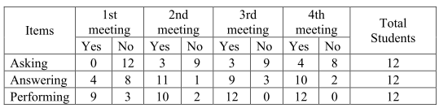

Graphic 1:
Graphic Format

Picture 1:
Picture Format
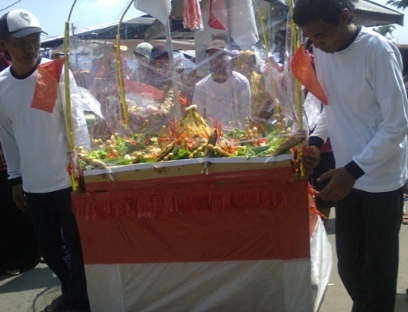
Source: xxxxxx

CONCLUSION

The conclusion section contains a summary of the research findings, which correlate with the research objectives written in the introduction. Then state the main points of the discussion. A conclusion generally concludes with a statement about how the research work contributes to the field of study as a whole (shows how progress from the latest knowledge). A common mistake in this section is to repeat the results of an experiment, abstract, or be presented with a very list. The concluding section must provide clear scientific truths. In addition, the conclusions can also provide suggestions for future experiments.

ACKNOWLEDGEMENT (Optional)
In the acknowledgment section, the author can state the source of research funding and more specifically to the contract number. Make sure the statement complies with the guidelines provided by the funding agency. The author can also express his thanks to reviewers and proofreaders, or technicians who help prepare equipment set-ups or students who assist in surveys.

REFERENCES

Usually, there are more errors in references than other parts of the manuscript. However, with reference management software, it is now easier to avoid this problem. In the text, the author must quote all references referred to and vice versa. Minimize the use of personal communication, do not include unpublished observations, manuscripts that have not been received for publication, publications that are not reviewed by reviewers, or gray literature. Prioritize articles in English and articles from reputable journals. Majority references for last 10 years, and 15 minimum references.
To make accountable references, the author can use reference management software, such as Mendeley. Make a list of references and citations in text that fit the APA 7th Edition style. Example of writing references in APA 7th Edition style:

[Format of Reference from Book]
Tong, R. P. (2009). Feminist Thought: A More Comprehensive Introduction. University of North Carolina, Charlotte. Colorado: Westview Press. https://doi.org/10 9 8 7 6 5 4 3 2 1

[Format of Reference from Antology]
Nimni, E. (2010). After the Nation?: Critical reflections on nationalism and postnationalism. In K. Breen & S. O’Neill (Eds.), After the Nation?: Critical reflections on nationalism and postnationalism (pp. 21–37). Hampshire: PALGRAVE MACMILLAN.

[Format of Reference from Journal]
Pranowo, Y. (2013). Identitas Perempuan dalam Budaya Patriarkis: Sebuah Kajian tentang Feminisme Eksistensialis Nawal el Sa’adawi dalam Novel “Perempuan di Titik Nol.” MELINTAS. Retrieved from http://journal.unpar.ac.id/index.php/melintas/article/view/266

Format Numbering
Subtitle 1 (if any; font: cambria12 pt, bold.)

This part is written in English. The space is single. The font type is cambria. The font size is 12 pt. the margins are: a) left: 4.5 cm; b) top: 4 cm; c) right: 4 cm; and bottom: 4.

1. Sub Subtitle (font: cambria 12 pt, bold.)

a. Sub Sub Subtitle

i. Sub Sub Sub Subtitle

1) Sub Sub Sub Sub Subtitle

Provisions on Writing Template
- The length of the whole is between 3000 and 7000 words.
- The space is single.
- The font type is cambria
- The font size is 12 pt.
- The margins are: a) left: 4.5 cm; b) top: 4 cm; c) right: 4 cm; and bottom: 4.
- Choose APA reference style for quotation and references, using Mendeley application.

